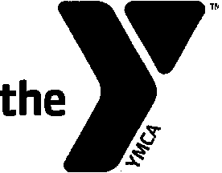
YMCA HOLIDAY BAZAAR & CRAFT SHOW
NOVEMBER 16, 2019 10AM- 4PM
2019 REGISTRATION FORM

Reserve your space today for the 39th Annual Holiday Bazaar on November 16, 2019! If you wish to reserve a table, please return this form and table fee (make checks payable to CLC YMCA). In order to encourage early registration, table cost is just $75 before July 31, 2019; after that date, the table fee is $95. All tables/spaces are filled on a first-come, first-served basis.

There will be NO REFUNDS for any reason. We will make every effort to honor requests for table location; however, the YMCA will adjust the layout as needed to most positively affect the overall bazaar. If you have questions, please call the CLC YMCA at (207)563-9622 or visit our website at clcymca.org.

We look forward to seeing you at the 2019 Holiday Bazaar!

39th Annual Holiday Bazaar - 2019 Registration
Return completed Registration Form to:
CLC YMCA, PO Box 787, Damariscotta, ME 04543

NAME: | PHONE:
BUSINESS NAME: | HAVE YOU ATTENDED THE CRAFT FAIR BEFORE? YES NO
TYPE OF CRAFT: | IF YES, FOR HOW MANY YEARS?
EMAIL ADDRESS: | WEBSITE ADDRESS:
MAILING ADDRESS: | TOWN: | STATE: | ZIP:
DO YOU NEED A TABLE?  YES NO | DO YOU NEED ELECTRICITY?  YES NO
SPECIAL REQUESTS:
# OF SPACES YOU WOULD LIKE TO RESERVE: | x $75.00  After July 31, 2019 rate is $95.00 | TOTAL ENCLOSED

I understand that there will be no refunds for any reason for my reserved space at the 2019 CLC YMCA Holiday Bazaar.
Signed Date: -
---------

